AUDIO
How to record and publish an audio clip with audioBoom

This project has been funded with support from the European Union. This publication reflects the views only of the author, and the Commission cannot be held responsible for any use which may be made of the information contained therein.

What is audioBoom
audioBoom is an online audio distribution platform based in London, New York, San Francisco and Sydney, allows users to listen to, record and share sound files.

How to create an account
Register in https://audioboom.com/
It allows to create an account using Twitter account or sign up with email/password.

Apps
Android App - https://play.google.com/store/apps/details?id=com.audioboom
iOS (Apple) App - https://itunes.apple.com/us/app/audioboom/id305204540?mt=8

Conditions
It is free to use, with a limitation of recording 10 minutes per clip to upload, though users can pay for longer record times. There is currently no upper limit to how many clips a user can upload.

Help links
Help centre - http://support.audioboom.com/hc/en-us
Video tutorial - https://youtu.be/JLSsKafdbFw

Profile and other features
Your account shows your dashboard with all your sound tracks. It shows followers, posts, etc.
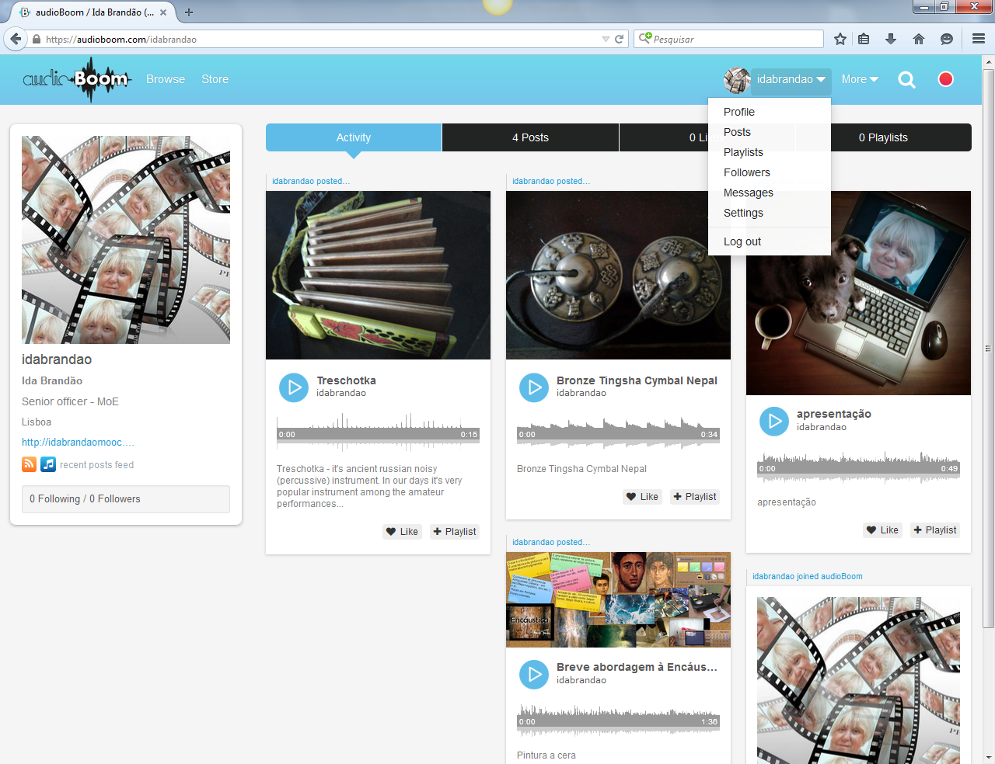
Ilustração 1 - audioBoom screen with dashboard, all tracks produced

How to get started
In the upper menu you have «More», a drop down menu to «get started» and see the free and paid schemes.
To upload or record a file you have to click in the red circle in the menu.
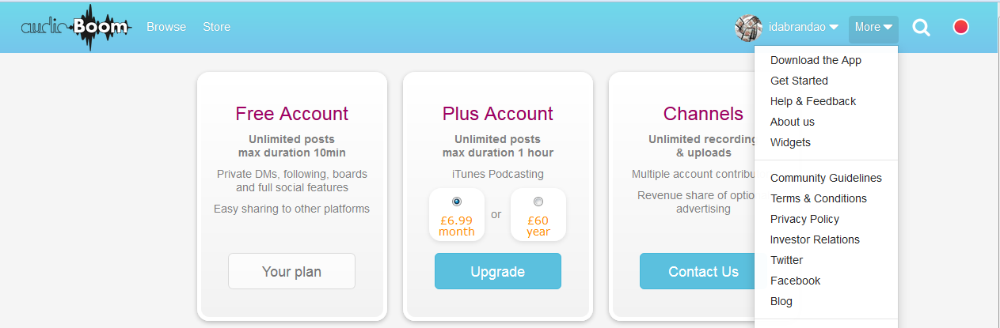
Ilustração 2 - audioBoom screen with free and payment acheme

Upload a file
To upload a file from your computer, you can drag and drop. The screen shows some fields to write a title of the audio clip and a description. You can upload an image related to the audio file, so that it may be easier to identify it in the dashboard. 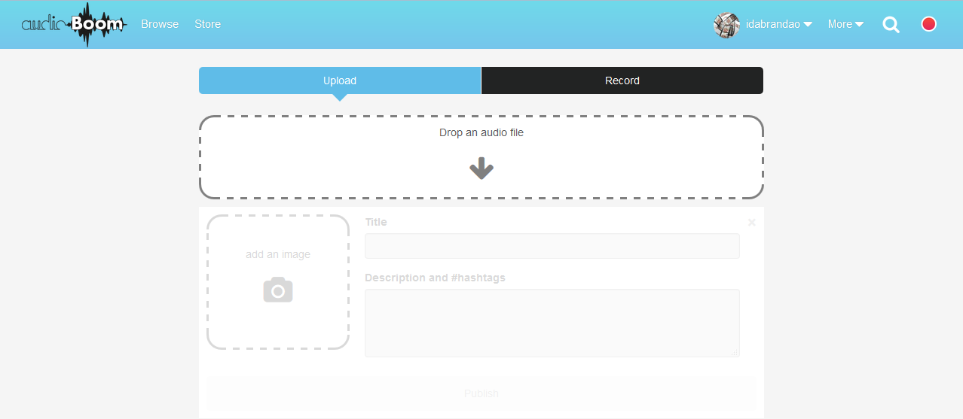
INSERT IMAGE
Ilustração 3 - audioBoom screen with upload and record features

Record a sound clip
Advice to record: prevent and avoid noise when you are recording; a good micro captures sound with better quality.
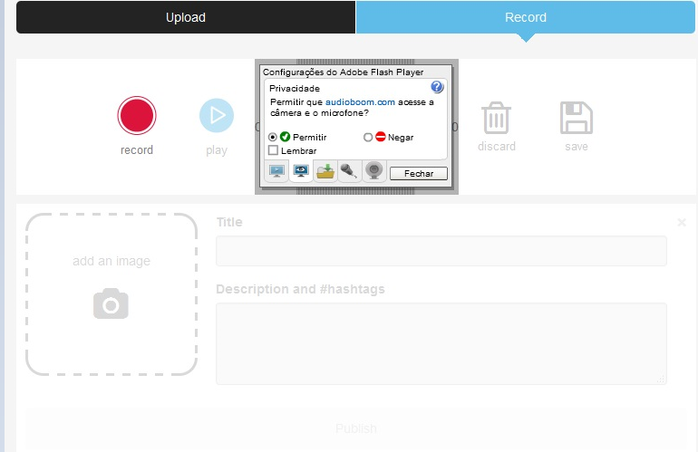
ALLOW MICRO
Ilustração 4 - audioBoom screen with record feature and permission to allow micro

Share
It provides an URL for each audio file and it allows to share in Twitter, direct button. It provides code to embed in websites.
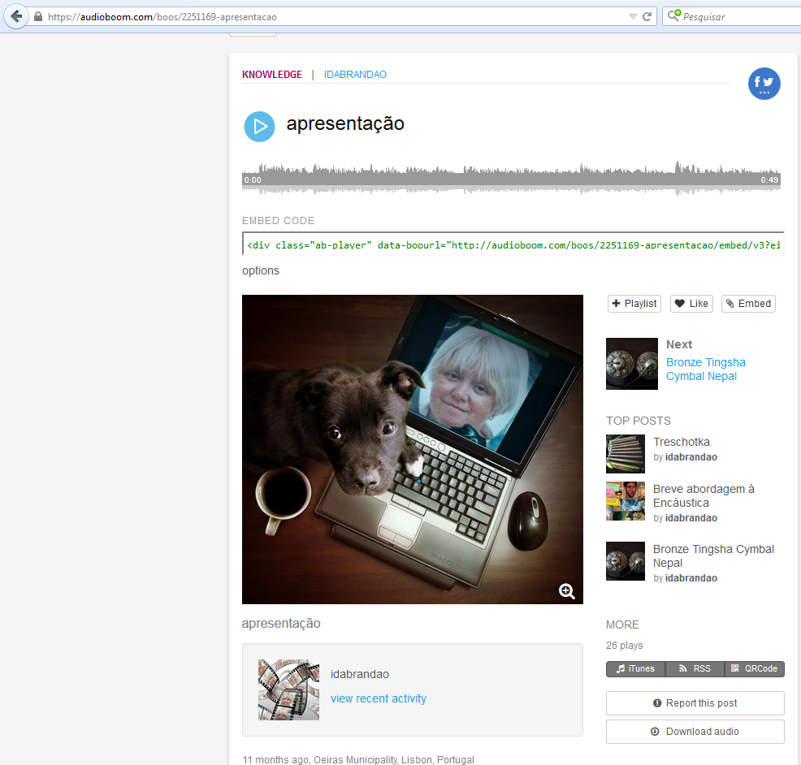
EMBED CODE
SHARE IN TWITTER
Ilustração 5 - audioBoom screen with embed code and share button

